**WEEK – 4**

**MANDATORY HANDS-ON - 2. spring-rest-handson**

1. **Hello World RESTful Web Service**

**STEP 1: Create Spring Boot Project**

1. Go to: <https://start.spring.io>
2. Fill the fields:
   1. Group: com.cognizant
   2. Artifact: spring-learn-rest
3. Add dependencies:
   1. Spring Web
4. Click on "Generate" to download the project zip.
5. Extract the ZIP to Eclipse workspace folder.

**STEP 2: Import the Project into Eclipse**

1. Open Eclipse.
2. Go to File > Import.
3. Select Maven > Existing Maven Projects → Next.
4. Browse and select the extracted spring-learn-rest folder.
5. Click Finish.

**STEP 3: Create the HelloController**

**📁 Location: src/main/java/com/cognizant/springlearn/controller/HelloController.java**

Right-click **src/main/java** → New → Package → Name it **com.cognizant.springlearn.controller**  
Then inside it, create a new class named **HelloController**:

The following code should be present:

package com.cognizant.springlearn.controller;

import org.slf4j.Logger;

import org.slf4j.LoggerFactory;

import org.springframework.web.bind.annotation.GetMapping;

import org.springframework.web.bind.annotation.RestController;

*@RestController*

public class HelloController {

private static final Logger ***LOGGER*** = LoggerFactory.*getLogger*(HelloController.class);

*@GetMapping*("/hello")

public String sayHello() {

***LOGGER***.info("START");

String message = "Hello World...!!!";

***LOGGER***.info("END");

return message;

}

}

**SpringLearnApplication.java (in com.cognizant.springlearn).**

package com.cognizant.springlearn;

import org.springframework.boot.SpringApplication;

import org.springframework.boot.autoconfigure.SpringBootApplication;

*@SpringBootApplication*

public class SpringLearnApplication {

public static void main(String[] args) {

SpringApplication.*run*(SpringLearnApplication.class, args);

}

}

**STEP 4: Update Application Properties**

To make sure it runs on port 8083:  
📁 **src/main/resources** → **application.properties**

Add this:

server.port=8083

**STEP 5: Run the Application**

1. Right-click **SpringLearnApplication.java** (in com.cognizant.springlearn).
2. Choose Run As > Java Application.
3. Wait for console to show:  
   Tomcat started on port 8083...

**STEP 6: Test the REST Endpoint**

1. Open Chrome or any browser.
2. Enter the URL: <http://localhost:8083/hello>
3. You should see:

**Hello World...!!!**

**We get this ->**

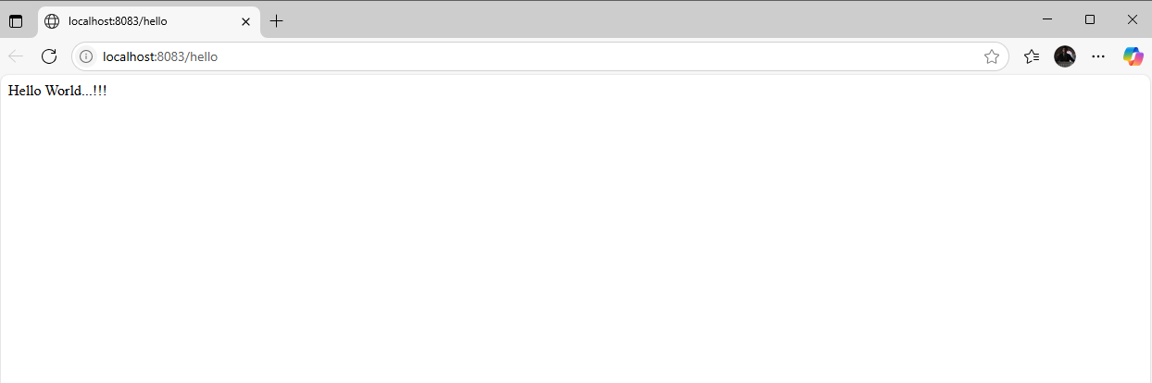

1. **REST - Country Web Service**
2. **Step 1: Create Project using Spring Initializr**
   * 1. Go to <https://start.spring.io>

**Fill in:**

* + - * Project: Maven
      * Language: Java
      * Spring Boot: 3.5.3 (latest)
      * Group: com.cognizant
      * Artifact: spring-learn-country-rest
      * Name: spring-learn-country-rest
      * Package name: com.cognizant.spring_learn_country_rest
      * Packaging: Jar
      * Java: 21

**Select Dependencies:**

* + - * Spring Web
    1. Click Generate → Download and extract the zip.

#### **Step 2: Import Project into Eclipse**

1. Open Eclipse IDE
2. Go to File → Import → Existing Maven Projects
3. Browse to the extracted folder
4. Click **Finish**

1. **Step 3: Create Configuration XML**

* File: country.xml  
  📍 Location: src/main/resources/country.xml

<?xml version="1.0" encoding="UTF-8"?>

<beans xmlns="http://www.springframework.org/schema/beans"

xmlns:xsi="http://www.w3.org/2001/XMLSchema-instance"

xsi:schemaLocation="http://www.springframework.org/schema/beans

https://www.springframework.org/schema/beans/spring-beans.xsd">

<bean id="country" class="com.cognizant.spring_learn_country_rest.Country">

<property name="code" value="IN"/>

<property name="name" value="India"/>

</bean>

</beans>

1. **Step 4: Create Country class**

* Package: com.cognizant.spring_learn_country_rest.model  
  File: Country.java

package com.cognizant.spring_learn_country_rest;

import org.slf4j.Logger;

import org.slf4j.LoggerFactory;

public class Country {

private static final Logger ***LOGGER*** = LoggerFactory.*getLogger*(Country.class);

private String code;

private String name;

public Country() {

***LOGGER***.debug("Inside Country Constructor");

}

public String getCode() {

***LOGGER***.debug("Getting code: {}", code);

return code;

}

public void setCode(String code) {

***LOGGER***.debug("Setting code: {}", code);

this.code = code;

}

public String getName() {

***LOGGER***.debug("Getting name: {}", name);

return name;

}

public void setName(String name) {

***LOGGER***.debug("Setting name: {}", name);

this.name = name;

}

*@Override*

public String toString() {

return "Country [code=" + code + ", name=" + name + "]";

}

}

1. **Step 5: Create Controller Class**

* Package: com.cognizant.spring_learn_country_rest.controller  
  File: CountryController.java

package com.cognizant.spring_learn_country_rest.controller;

import com.cognizant.spring_learn_country_rest.Country;

import org.slf4j.Logger;

import org.slf4j.LoggerFactory;

import org.springframework.context.ApplicationContext;

import org.springframework.context.support.ClassPathXmlApplicationContext;

import org.springframework.web.bind.annotation.RequestMapping;

import org.springframework.web.bind.annotation.RestController;

*@RestController*

public class CountryController {

private static final Logger ***LOGGER*** = LoggerFactory.*getLogger*(CountryController.class);

*@RequestMapping*("/country")

public Country getCountryIndia() {

***LOGGER***.info("START");

ApplicationContext context = new ClassPathXmlApplicationContext("country.xml");

Country country = context.getBean("country", Country.class);

***LOGGER***.info("END");

return country;

}

}

1. **Step 6: Run the Application**

* File: SpringLearnCountryRestApplication.java
* Right-click → **Run As → Java Application**

#### **Step 7: Test the Output**

* Open browser or Postman and go to:

<http://localhost:8085/country>

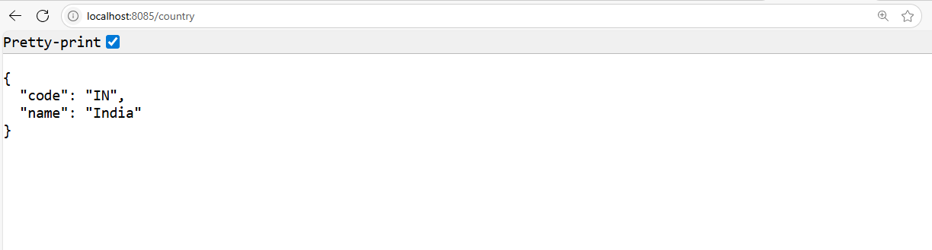

1. **REST - Get country based on country code**

#### **Step 1: Create Project Using Spring Initializr**

* + 1. Go to <https://start.spring.io>
    2. Fill in:
       1. **Group:** com.cognizant
       2. **Artifact:** spring-learn-countrycode-rest
       3. **Name:** spring-learn-countrycode-rest
       4. **Package Name:** com.cognizant.spring_learn_countrycode_rest
       5. **Java Version:** 21
    3. Select **Dependencies**:
       1. Spring Web
    4. Click **Generate**, then download and extract.

1. **Step 2: Import into Eclipse**

* In Eclipse → File → Import → Existing Maven Projects
* Select the extracted folder
* Click **Finish**

1. **Step 3: Create Configuration XML**

* File: country.xml
* Location: src/main/resources/country.xml

<?xml version="1.0" encoding="UTF-8"?>

<beans xmlns="http://www.springframework.org/schema/beans"

xmlns:xsi="http://www.w3.org/2001/XMLSchema-instance"

xsi:schemaLocation="http://www.springframework.org/schema/beans

https://www.springframework.org/schema/beans/spring-beans.xsd">

<bean id="countryList" class="java.util.ArrayList">

<constructor-arg>

<list>

<bean class="com.cognizant.spring_learn_countrycode_rest.Country">

<property name="code" value="IN" />

<property name="name" value="India" />

</bean>

<bean class="com.cognizant.spring_learn_countrycode_rest.Country">

<property name="code" value="US" />

<property name="name" value="United States" />

</bean>

<bean class="com.cognizant.spring_learn_countrycode_rest.Country">

<property name="code" value="DE" />

<property name="name" value="Germany" />

</bean>

<bean class="com.cognizant.spring_learn_countrycode_rest.Country">

<property name="code" value="FR" />

<property name="name" value="France" />

</bean>

<bean class="com.cognizant.spring_learn_countrycode_rest.Country">

<property name="code" value="JP" />

<property name="name" value="Japan" />

</bean>

</list>

</constructor-arg>

</bean>

</beans>

1. **Step 4: Create Country Class**

* Package: com.cognizant.spring_learn_countrycode_rest.model  
  📄 File: Country.java

package com.cognizant.spring_learn_countrycode_rest;

public class Country {

private String code;

private String name;

public Country() {}

public String getCode() {

return code;

}

public void setCode(String code) {

this.code = code;

}

public String getName() {

return name;

}

public void setName(String name) {

this.name = name;

}

*@Override*

public String toString() {

return "Country [code=" + code + ", name=" + name + "]";

}

}

1. **Step 5: Create CountryController**

* Package: com.cognizant.spring_learn_countrycode_rest.controller  
  📄 File: CountryController.java

package com.cognizant.spring_learn_countrycode_rest.controller;

import org.springframework.beans.factory.annotation.Autowired;

import org.springframework.web.bind.annotation.*;

import com.cognizant.spring_learn_countrycode_rest.Country;

import com.cognizant.spring_learn_countrycode_rest.service.CountryService;

*@RestController*

public class CountryController {

*@Autowired*

private CountryService countryService;

*@GetMapping*("/countries/{code}")

public Country getCountry(*@PathVariable* String code) {

return countryService.getCountry(code);

}

}

1. **Step 6: Run Spring Boot App**

* File: SpringLearnCountrycodeRestApplication.java
* Right-click → Run As → Java Application

package com.cognizant.spring_learn_countrycode_rest;

import org.springframework.boot.SpringApplication;

import org.springframework.boot.autoconfigure.SpringBootApplication;

*@SpringBootApplication*

public class SpringLearnCountrycodeRestApplication {

public static void main(String[] args) {

SpringApplication.*run*(SpringLearnCountrycodeRestApplication.class, args);

}

}

1. **Step 7: Test the API**

* Open browser or Postman:
* <http://localhost:8086/country/in>

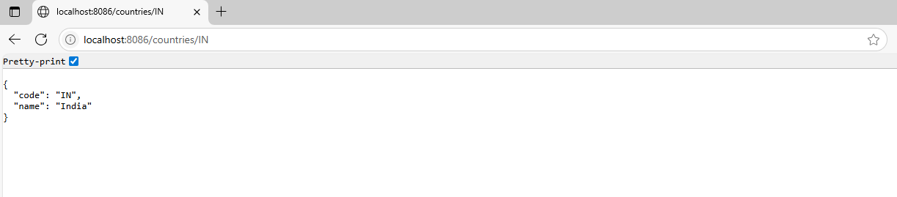

* <http://localhost:8086/country/jp>

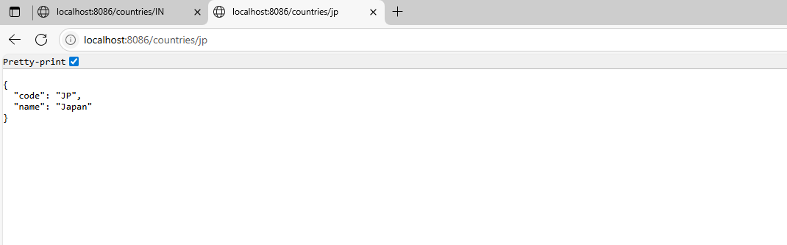

* <http://localhost:8086/country/us>

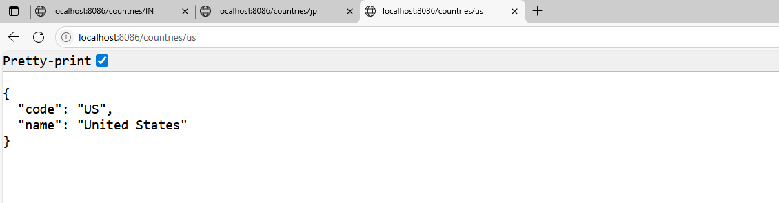

* <http://localhost:8086/country/FR>

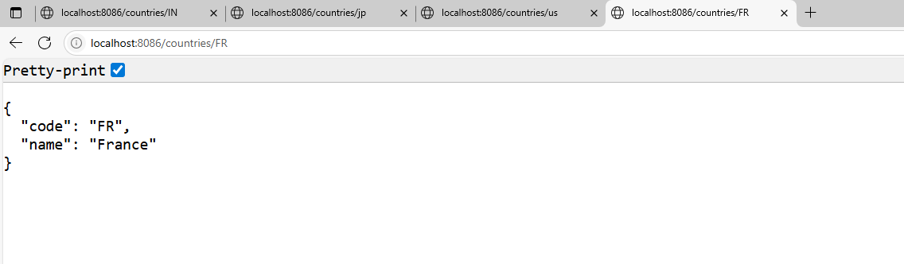

* <http://localhost:8086/country/de>

